# Business Requirement Document (BRD)

## Credit Memo for Vendor Invoices in ApWorks

## 1. Introduction

In ApWorks, once a vendor invoice is posted, it becomes immutable, meaning it cannot be modified or deleted.

However, errors such as incorrect tax calculations, overbilling, or duplicate processing can still occur.   
Since modifying a posted invoice is not an option, there needs to be a structured mechanism to reverse or adjust such invoices while ensuring financial accuracy and compliance.  
   
The implementation of Credit Memos will provide users with a way to rectify mistakes systematically, without compromising the integrity of the financial system.

## 2. Business Need

A Credit Memo serves as an adjustment tool to reverse a previously issued vendor invoice.   
 This functionality is essential for cases such as:  
 - User Errors – Incorrect amounts, tax miscalculations, or wrong vendor details.  
 - Overbilling – The vendor charged more than the agreed amount.  
 - Duplicate Invoices – The same invoice was processed multiple times.  
 - Service Not Rendered – The invoice was generated for a service that was later canceled.  
   
With this release, ApWorks will only allow full Credit Memos, meaning users can only issue Credit Memos that completely reverse the original invoice amount.

Reversed Amount = Original Invoice Amount × (-1)  
   
 Example:  
   
 - Original Invoice: INV1001, Amount = $500  
 - Credit Memo: INV1001_CR, Amount = -$500 (full reversal)

## 3. Credit Memo Processing Flow

3.1 **Initiating a Credit Memo**  
 - Users navigate to the Vendor Invoice Screen.  
 - Users select a posted invoice and click on "Credit Memo".  
 - A confirmation prompt ensures the user intends to issue a full credit.  
 - once user confirms, System will create a reversal invoice once user confirms the prompt.

* Reversal Invoice (Credit memo) will be in a read-only state, and users cannot make any changes to invoice except fields mentioned in UI section (needs to review if we should allow to update any other field)
* Please note that approval will not be required for Reversal Invoices, that’s why reversal invoices will be excluded from approvals. However, after creation Reversal Invoice will directly show up in Approved invoice list and will be ready to post.

3.2 **System Validations**  
  
 - Only fully posted invoices are eligible for Credit Memos.  
 - The system automatically sets the Credit Memo amount equal to the

Full invoice amount *-1 (partial credits are not allowed).  
 - The system prevents multiple Credit Memos from being issued for the same invoice. Once Credit memo is created for invoice, “Credit Memo option will be disabled for such invoice.”  
   
 3.3 **Credit Memo Numbering**  
 - The system generates a new Credit Memo invoice number as:  
 - Original Invoice Number + "_CR"  
 - Example: If original invoice = INV1001, then Credit Memo = INV1001_CR.  
   
 3.4 **Handling Reprocessed Invoices**  
   
- If a user needs to reprocess an invoice ( with same invoice Number) after issuing a Credit Memo:  
 - The system should not mark invoice as a duplicate if existing invoice has been fully credited.  
 - Duplicate invoice numbers for the same vendor are not allowed.  
 - The system will append an incrementing suffix (_1, _2, etc.) to the invoice number if invoice number already exists.  
 - If the invoice number exceeds the allowed length, it is truncated from the left.

## 4. Business Rules

4.1 Permission for Create and Post Credit Memo  
 - Separate permission for Create and Post Credit memo will be added under the user management section for each module. These rules will indicate who can create Credit memo and who can post credit memo.  
  
[Question:] Do we need Credit Feature for PDF based Broadcast? We can’t provide this for EDI for sure as one EDI can have multiple invoices but for PDF based broadcast, we can possibly provide Credit memo option. However, we need to confirm it with Imran and US team.

4.2 Handling Reprocessed Invoice Numbers  
 - Ensures unique invoice identification.  
 - Prevents overwriting of existing invoices.  
 - Maintains financial system integrity.  
  
 4.3 No Credit Memo Reversals  
 - Once a Credit Memo is issued and posted, it cannot be reversed.  
 - If a mistake occurs, users must reprocess the invoice as a new entry.  
  
 4.4 No Debit Memo for a Credit Memo  
 - Users cannot create a Debit Memo to offset a Credit Memo.  
 - however, If a negative invoice (Credit Invoice, trough regular process i.e. Invoice processing and manual invoice creation) is posted and needs reversal, it is treated as a Debit Memo.  
  
4.5 No Multiple Credit Memos for the Same Invoice  
 - Once a Credit Memo has been issued, another Credit Memo cannot be created for the same invoice.  
   
4.6 Invoice Number Truncation  
 - If the invoice number exceeds the maximum field length, the system truncates it from the left side.  
   
4.7 Unapproved Invoices Cannot be Credited  
 - Only fully posted invoices can be credited, ensuring financial consistency.  
  
4.8 Approval Workflow for Credit Memos  
Approvals will not be applicable for Reversal invoice.

4.9 System Logs & Audit Trail  
 - Every Credit Memo action is logged for audit and compliance purposes.  
   
 4.9 Handling Vendor-Issued Credit Memos (Future Consideration)  
 - Vendor-issued Credit Memos are not supported in this release but may be added in the future.

## 5. Exclusions

The following functionalities are excluded from this release due to system constraints, process complexities, and the need for further evaluation before implementation. These exclusions may be considered for future enhancements:  
   
Vendor-Issued Credit Memos:  
- ApWorks will not currently support vendor-issued Credit Memos as it requires additional validation checks, reconciliation mechanisms, and approval workflows.  
   
Reporting Adjustments:  
Reports changes will be handled separately.  
   
Deleting Approved Invoices:  
- Once an invoice is approved, it cannot be deleted in ApWorks to maintain auditability and compliance. Users must issue a Credit Memo instead.

## 6. UI Mockups

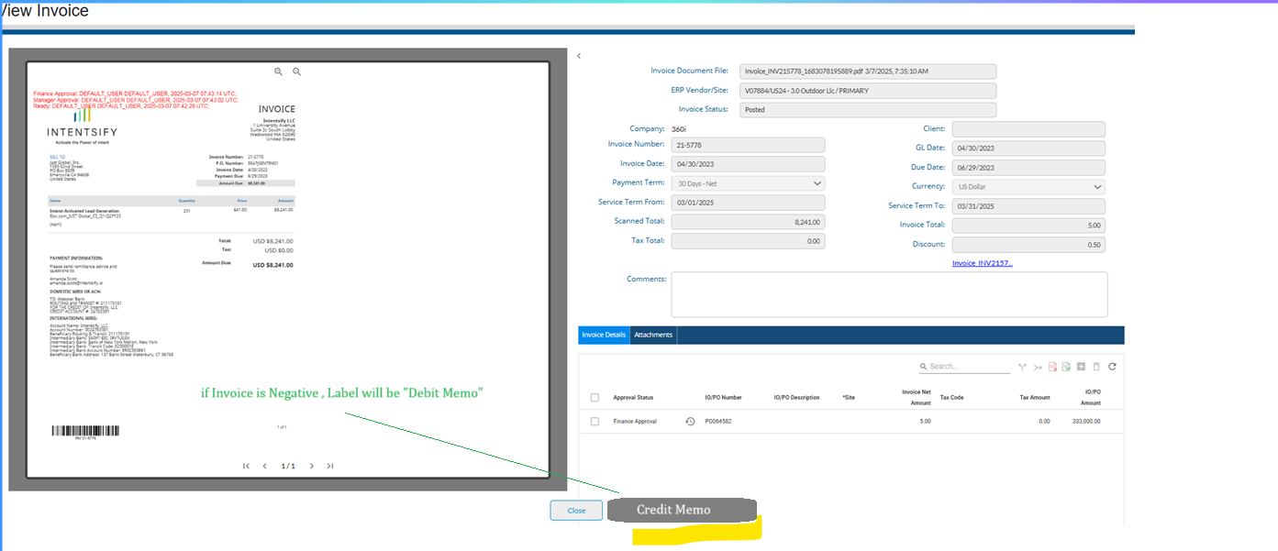

Once user clicks on “Credit Memo / Debit memo” button, System will create reversal of invoice by multiplying amount with -1. Following will be actions behind click of “Credit Memo / Debit Memo”.  
  
Consider the Invoice as following.  
  
Doc Number: DOC0000001  
Invoice Number: 0000001  
Invoice Date: 04/30/2025  
GL Date: 04/30/2025  
Due Date: 06/29/2025

1. User clicks on “Credit Memo / Debit Memo” Button.
2. System will call an SP to Create reversal Invoice and will send Invoice Number / Document Number “DOC0000001 / 0000001” to SP.
   1. SP will verify if Invoice is posted or not, if not posted, SP will throw an error that Credit memo can’t be created for unposted invoice.
   2. SP will verify that invoice is not a Credit memo itself, if it is credit / debit memo, SP will throw an error that Debit Memo / Credit Memo cannot be created for this invoice.
   3. SP will verify if there is existing Credit Memo / Debit Memo Created for invoice.
      1. If created.
         1. Will throw an Error that Credit Memo / Debit Memo already exists.
      2. If not created.
         1. Will proceed with step “b”
   4. SP will create Copy of Invoice as reversal invoice with following updates.
      1. New Docu number will be assigned.
      2. Invoice will be marked as Credit Mem
      3. Invoice Number will updated to invoice **number +”_CR”** i.e. “0000001_CR”
      4. SP will default GL date, invoice date and due date to current date.
      5. The same invoice document as the original invoice will be used for the Credit/Debit Memo.
         1. Sp or application will copy the document from the original invoice for Credit Memo and will update file path.
      6. SP will return the newly created Docu ctrl ID to application.
   5. Application will load new document using Credit Memo / Debit Memo ctrl Id (system will auto create watermark on invoice as “CREDIT Memo “ and Name of person who is crediting the invoice i.e. Credit Memo Created by CREATER NAME ON DATETIME)
   6. 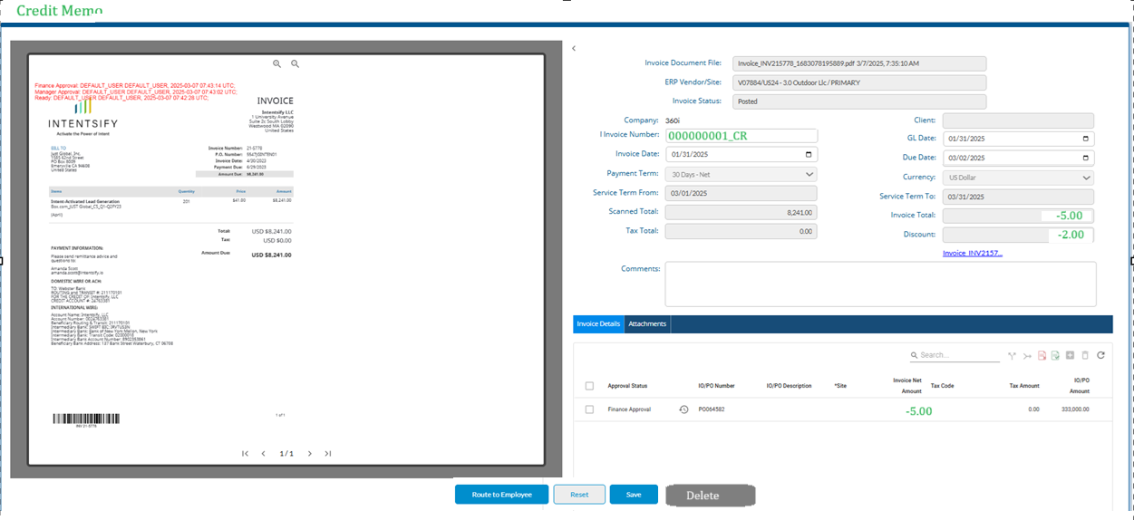

Img 1.1 (Route to Employee button is not needed for Credit Memo)

* 1. Only the following fields will be enabled.
     1. Invoice Number.
     2. Invoice date
     3. GL date
     4. Due Date
  2. Rest of all fields and actions (except Delete , Save and reset) will be disabled.

1. As approval is not applicable for Credit Memo that’s why Once Credit Memo is created, it will be directly available in approved Invoice gadget and vendor invoice report and will be available for posting based on rule.
   1. Only authorized people can post credit memos. However, if we display approved invoices to all users (not just one who are on approval list) that we need to have same logic for credit memo as well. For example, Credit memo will be visible to all, but only authorized person can post it.

However, if we don’t display approved Invoice to all resource and display it to only authorize persons that we should display Credit memo to only authorized persons (who has authority to create or post credit memo).

## 7. Risks & Considerations

Duplicate Reprocessing: The system must correctly handle repeated attempts to reprocess invoices.  
  
- Manual Entry Errors: Users must ensure they select the correct invoice before issuing a Credit Memo.  
  
- Future Enhancements: Vendor-Issued Credit Memos may be introduced later, requiring system modifications.

## 8. Conclusion

The Credit Memo feature in ApWorks ensures that invoice corrections are handled systematically without modifying posted invoices.   
  
By enforcing full reversals, strict validation rules, and unique numbering, this functionality maintains financial accuracy while giving users the flexibility to correct mistakes effectively.